**Experiment: 9**

**Student Name: Rishav Kumar UID: 22MCC20039**

**Branch: MCA - CCD Section/Group: 22MCD1 / Grp A**

**Semester: II Date of Performance: 4th May 2023**

**Subject Name: Software Testing Subject Code: 22CAH-685**

**Q. How to create a team Epic?**

* Open Jira dashboard, and click on Teams > Invite people to jira.

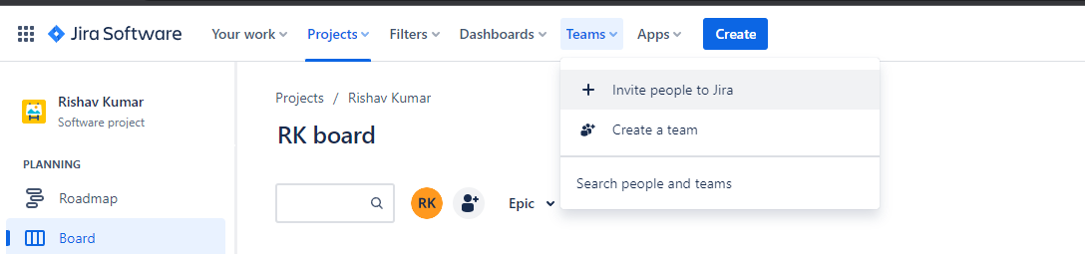

* Enter gmail address of people to invite them to jira.
* After accepting your request, click on Teams > Create a team.
* Enter name of your team and its members.

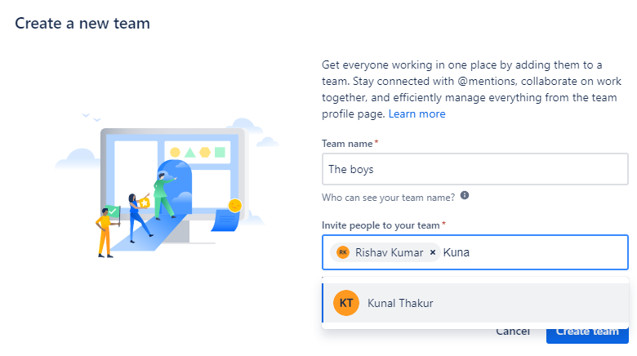

* Click on create team.
* Now to assign a task to team member, click on create.

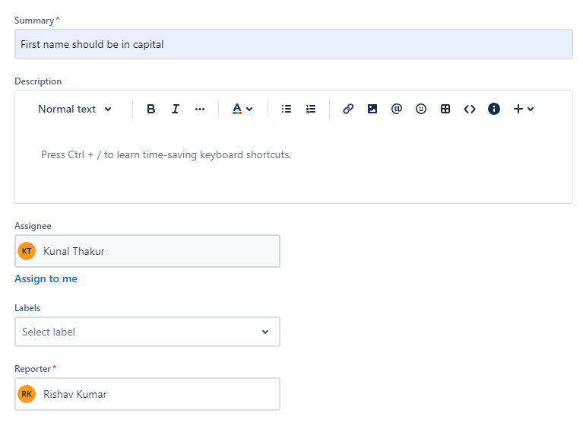

* Enter summary and description for task.
* Click on Asignee and select your team member to which you want to assign.
* Select start date and end date.
* Click on Create button.
* Your tasks will be visible on your dashboard.

